DEBANJAN MAZUMDAR

+91 – 7406242230/ 9035044601

Email: debanjan186@gmail.com

Current Location: Pune, Maharashtra

LinkedIN ID:https://www.linkedin.com/in/debanjan-mazumdar-1161295a/

Overview

- 7+ years of experience in Manual and Automation testing.

- Hands on experience in architecting and designing test automation framework and deep understanding of tools such as TestNG and Selenium Web driver with Java

- Good knowledge of all phases of STLC with Functional & Regression Testing.

- Collaborated with cross-functional team such as developers, QAs, Business Analysts to design and develop automated test scenarios and assisted them to use automation.

- Decent exposure with foreign clients and team members.

- Managed team of 2-3 junior members.

Technical Skills
Automation Tools |  | Selenium, REST, TestNG
Testing |  | Black box, Smoke, Functional, Integration, UI, Regression, System
Test Management |  | HP ALM
SDLC cycle |  | Agile, Waterfall
Defect Tracking Tools |  | JIRA, Bugzilla
Package Management |  | Maven
CI Tools |  | Jenkins
Database |  | MySQL
Programming Languages |  | Java
VCS |  | GIT
IDE |  | IntelliJ IDEA, Eclipse
OS |  | Mac, Windows
Virtualization |  | VMWare ESXi, VMware VCenter
Domain |  | Cloud, Web, Mobile, Banking
Interested in |  | Artificial Intelligence, Amazon cloud, Devops


Previous Employers

Avaya India Pvt Ltd (6th July 2015- 30th March 2018)

IDrive India Pvt Ltd (1st April 2013- 3rd July 2015)

Tata Consultancy Services (25th November 2010- 30th March 2013)
Relevant Project Experience

Company: Avaya India Pvt Ltd

Product: System Manager


Avaya India Pvt Ltd

Duration

February 2017 – March 2018

Technology

Tools
Selenium Webdriver using Java and TestNG

Bug Reporting Tool: JIRA

Test Management Tool: HP ALM

O/S: Windows OS
Package Management: MAVEN
VCS: GIT

Role

TEAM MEMBER, MENTOR

Product: AvayaLive E Store, Snappstore
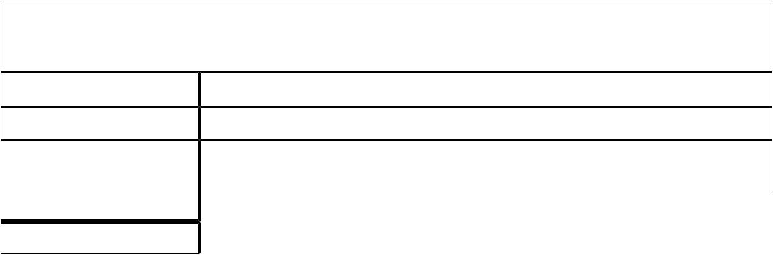

Avaya India Pvt Ltd
Duration |  |  | July 2015 – February 2017
Technology |  |  | Selenium Webdriver using Java and TestNG
Tools |  |  | Bug Reporting Tool: JIRA
 |  |  | Test Management Tool: HP ALM
 |  |  | O/S: Windows OS
Role |  |  | INDIVIDUAL CONTRIBUTOR

Company: IDrive India Pvt Ltd

Product: IDrive, IBackup
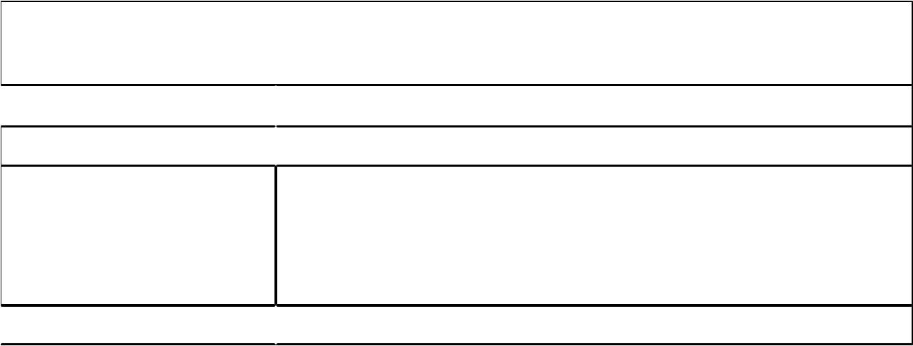

IDrive India Pvt Ltd

Duration

April 2013 – July 2015

Technology

Tools
Objective C, Mac Scripting Language

Bug Reporting Tool: Bugzilla

Database: MSQLite

O/S: MAC OS X, Windows OS

Other tools: svnX

Role

TEAM MEMBER

Company: Tata Consultancy Services

Client: Apple Customer Database- Cupertino, USA


Apple-GCRM

Duration

February 2012 – November 2012

Technology

Tools
Java

Bug Reporting Tool: RADAR

Database: SQL Developer

Load Testing Tool: AppPerfect Load Test

O/S: MAC OS X

Role

TEAM MEMBER

Client: Bank Of America – Charlotte, USA


Bank Of America- Customer Systems Testing

Duration | February 2011 – December 2011
Technology | Mainframes
Tools | Test Management Tool/ Bug Reporting Tool: HP Quality
 | Center 10.0
 | Database: IBM Mainframes
 | O/S: Windows XP
Role | TEAM MEMBER

Educational Qualification:

- Bachelor of Engineering, specialized in Information Science Engineering from CMR Institute of Technology, Bangalore (University – Visvershwarya Technological University) in the year 2010 with 70.02%.

- Class 12th from D.A.V. Jawahar Vidya Mandir, Ranchi (Board- C.B.S.E) in the year 2005 with 69.8%.

- Class 10th from D.A.V. Hehal, Ranchi (Board- C.B.S.E) in the year 2003 with 93.6%.

Areas of Strength

- I am a very good Team player.
- Always willing to learn and take responsibilities.

- I have excellent verbal and written communication skills.

Additional Information

- Fluent in English, Hindi and Bengali.

- Interested in dance.

- Active member of Rockers club within Avaya, which organized and participated in all the events across the organization.

Personal Details

 | 18th June 1988
Date of | 18th June 1988
Birth
Nationality | INDIAN
Gender | Male
Permanent | S/o Mr. S. K. Mazumdar, C/o Sharma House, Cozy Corner,
Address | Burdwan Compound, Circular Road, Lalpur, Ranchi- 834001,
 | Jharkhand
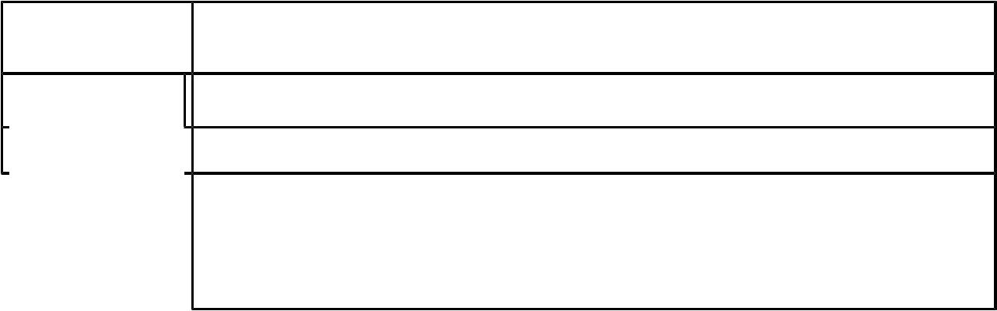

Passport Details
 | Name as on passport |  | Passport | Date of Issue | Expiry Date | Place of Issue
 |  |  | Number
 | Debanjan Mazumdar |  | J2190714 | 8th July 2010 | 7th July 2020 | Ranchi, IN


